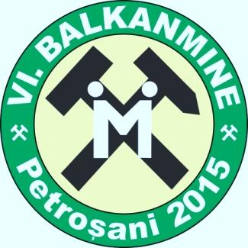 |  |  | VI BALKANMINE CONGRESS  Petroșani, Romania, 20-23 September 2015
CONGRESS PARTICIPATION REGISTRATION FORM
Please fill out the registration form and send it to roxana_balkanmine@yahoo.com and andras@upet.ro at the latest by 15 April , 2015.
PERSONAL DETAILS
Please carefully complete your personal details which will allow for continuous communication, and at the same time will be used in publication of the list of participants. Please use the printed letters for filling the Form.
PARTICIPANT DETAILS
Academic title:
First name: |  |  |  | Last name:
Institution:
Department:
Adress:
Postal code: |  |  |  |  | City:
Country: |  |  |  |  | Telephone number:
Fax: |  |  |  |  | e-mail:
Type of participation (Member of Comitee, Delegate, Exhibitor,Sponsor, Student, other):
PAPER DETAILS
Title of paper:
Language:
Fellow authors:
Presenting author
ACCOMPANYING PERSON(S)
First name: |  |  |  |  | Last name:
First name: |  |  |  |  | Last name:
Please write the abstract on next page according to indications.
Upon receipt of your registration form, a written notification will be sent to you about acceptation and payment info.

REGISTRATION FEES (Euro)
 | Before July 25th, 2015 | After July 25th, 2015
Authors/participants* | 250 | 350
Accompanying persons** | 100 | 130
Ph.D. students* | 75 | 100
*Registration fee includes: admission to scientific sessions, congress materials (Abstracts Book, CD with all published papers, Certificate of attendance), two lunches, coffee breaks, welcome cocktail, two dinners.
**Registration fee for accompanying persons includes: admission to special program, two lunches, welcome cocktail and two dinners.
Payment should be made by bank transfer, at the latest together with sending of final form of the paper in following account:
RO49BRDE220SV75500262200
Bank: BRD Petrosani, SWIFT: BRDEROBU
Branch address: Strada 1 Decembrie 1918 nr. 79 Petrosani
Account holder: FUNDATIA SFANTA MARIA, VAT No. 14984127
Adress: str. 1 Decembrie 1918, nr. 1, loc. Petrosani, jud. HD
Mention: Registration fee BALKANMINE 2015 , Name of participant

ABSTRACT

TITLE OF PAPER :
AUTHORS :

Key words :

Please write ½ page of abstract (Arial11)

send this page with registration form at
roxana_balkanmine@yahoo.com and andras@upet.ro

Please keep in mind the deadlines:
15 April 2015 – preliminary registration and abstract submission
30 April 2015 – notification of abstract acceptance
15 June 2015 – full paper submission (author’s guide will be sent together with the acceptance notification)
15 July 2015 – notification of paper acceptance
25 July 2015 – conference fee payment
1st September 2015 – final announcement and program

